**LTE ARCHITECTURE**

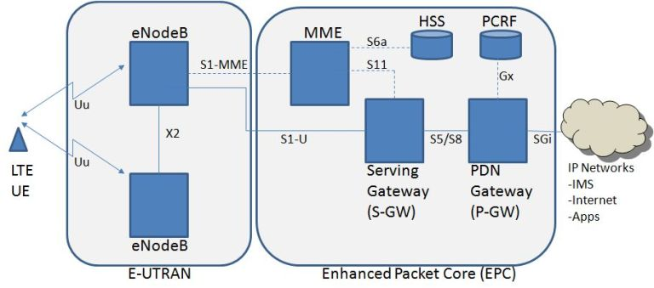

1. LTE consists of 3 main components:
   1. UE (user equipment)
   2. E-UTRAN (Evolved **UMTS** Terrestrial Radio Access Network )
   3. EPC( EVOLVED PACKET CORE)
   4. UE is the user equipment which Is used to dialing a number. UE connects with E-UTRAN with the basis of UM-AIR interface.
   5. E-UTRAN-

The E-UTRAN consists of eNBs, providing the E-UTRA user plane (PDCP/RLC/MAC/PHY) and control plane (RRC) protocol terminations towards the UE. The eNBs are interconnected with each other by means of the X2 interface. The eNBs are also connected by means of the S1 interface to the EPC (Evolved Packet Core), more specifically to the MME (Mobility Management Entity) by means of the S1-MME interface and to the Serving Gateway (S-GW) by means of the S1-U interface. The S1 interface supports a many-to-many relation between MMEs / Serving Gateways and eNBs.

1. The LTE Call Flow process

**1. Beacon (MIB, SIB)**

Master Information’s Block (MIBs) and System Information Block (SIBs) elements allow UE to find and sync itself to network.

**2. Random Access Preamble (RAP)**

Is the first message from the UE to eNB, to achieve uplink synchronization in order to obtain the resource for the third message.

**3. Random Access Preamble Response (RAP Response)**

Random Access Preamble response allows the UE to send further messages.

**4. Radio Resource Connection (RRC LTE)**

The UE uses UL-SCH allocation message to eNodeB which contains UE identity (typically S-TMSI: MMEC+M-TMSI) and the establishment cause for the RRC connection.

**5. Radio Resource Connection Setup (RRC Setup)**

eNodeB sends DL-SCH message to the UE in order to create the signaling radio bearer (SRB) . The message contains: configuration parameters for uplink RLC, UL-SCH, Power Head Room (PHR) and Uplink Power Control.

[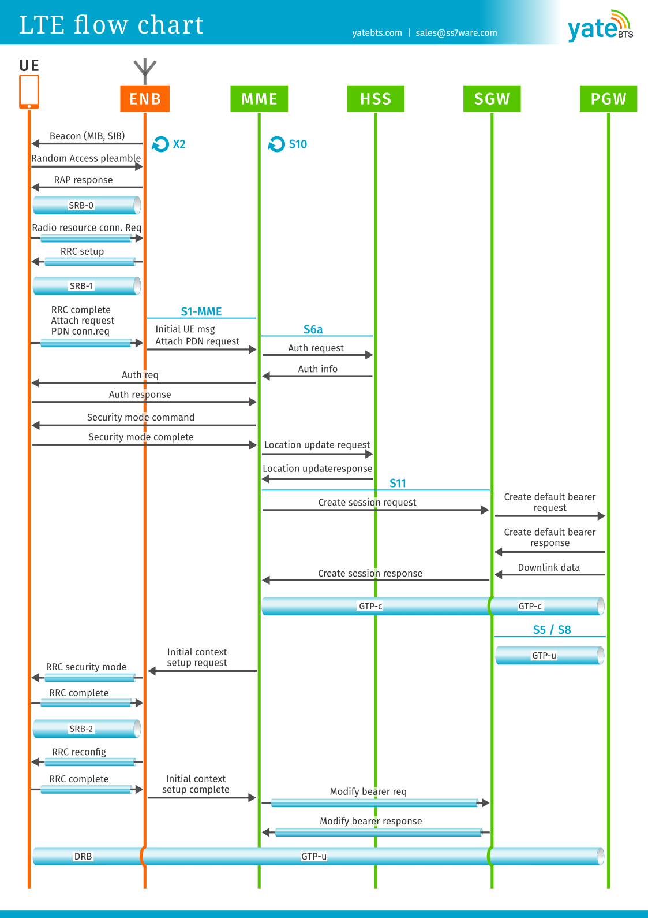](https://yatebts.com/wp-content/uploads/2020/02/LTE-call-flow.png)

**6. PDN Connectivity**

The UE sends a message to eNodeB which contains: RRC has been completed, Initiate the Attach procedure as Non-access stratum (NAS) payload and PDN Connectivity request.

**7. Attach PDN request**

eNodeB will send its first message to the core network passing the attach request to the MME. This message is sent via S1AP interface and it contains the initial UE message which includes: the PDN Connectivity Request , the Tracking Area Identify (TAI) and E-UTRAN Cell Global Identifier (ECGI).

**8. Authentication request and info**

The MME will reach the HSS will send the security tuple to the MME containing K-ASME, AUTN, XRES and RAND.

**9. Authentication response**

The UE sends the Autch response value which was computed from the key K, AUTN and RAND.

**10. Security Mode Complete**

Security mode command MME sends the encryption and integrity protection algorithms and key selection identifier (KSI-ASME). The UE response message back to the MME with NAS ciphering and integrity protection.

**11. Location update request**

Acknowledgment message sent from HSS to MME that contains PDN subscription contexts (EPS subscribed QoS profile and the subscribed APN-AMBR).

**12. Session request**

Create session request message from the Mobility Management Entity (MME) to the Serving Gateway(SGW) to create a GTP tunnel.

**13. Default Bearer Request**

Serving Gateway (SGW) will send this request to Packet Data Network Gateway (PGW), to create a new entry in its EPS bearer context table and generates a Charging Id.

**14 .Default bearer response**

The default bearer response from the PGW to the SGW will contain PDN GW User Plane address, PDN GW TEIDs User and Control Plane, EPS Bearer Identity and QoS. On the other hand, PGW will also send Downlink data that will be buffered in the SGW for now.

**15. Session response.**

Acknowledgement message from SGW to the MME that indicates the establishment of GPRS Tunneling Protocol for control (GTP-C) tunnle.

**16. Initial context setup request**

MME will send eNB initial context setup message containing S1 interface context setup request, NAS attachment accept and activate default bearer request.

**17. RRC security mode**

The eNodeB will reach the UE with RRC security mode message with the AS integrity protection and encryption algorithms and START parameters. The UE sends to eNodeB acknowledge message that uses the newly activated keys to encrypt and integrity protection.

**18. RRC reconfig**

eNodeB will send RRC reconfigure to activate the default radio bearer.

**19. RRC complete**

The next thing happening in the LTE call flow is that the UE will send acknowledgment message and attach RRC LTE complete (EPC Bearer Identity, NAS sequence number, NAS-MAC).

**20. Data flowing**

Now, the UE has successfully established a connection to the network and the buffered data will be passed to the UE in the Data Radio bearer.

1. **According to this info we design a new system for the Emergency MT (mobile terminating) calls.**

2.1. First message for making the connection to the network is MIB/SIB. This is the procedure which is done at the user equipment end after this process the user sends a RAP message to the e-Nodeb for providing a new channel.

**2.1.1. Initiation of RAP protocol.**

The complete procedure and the assumption that a network takes is present in the latest version of this file ETSI TS 136 321 V8.11.0.

After this process the UE is able to sends the further message to directly to the network

.

**2.1.2. UL-SCH (UP link Shared channel)**

By the help of this channel further process takes place. In this the CRC (Cyclic Redundancy check) process takes place. Complete information about this is present in the ETSI TS 136 321 V8.11.0.After the completion of our RRC channel setup. PDN connectivity comes into play.

**2.1.3. PDN connectivity request message**

This message is sent by the UE to MME. Content of this message request is

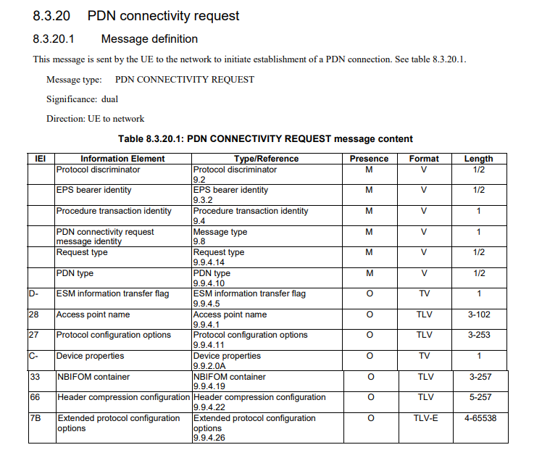

**Complete description is in the** ETSI TS 124 301 V15.3.0

**2.1.4 Attach request**

After this PDN request confirmation from the Network side message received by the UE it will immediately sends a attach request to core network i.e. MME. The attach request message content is.

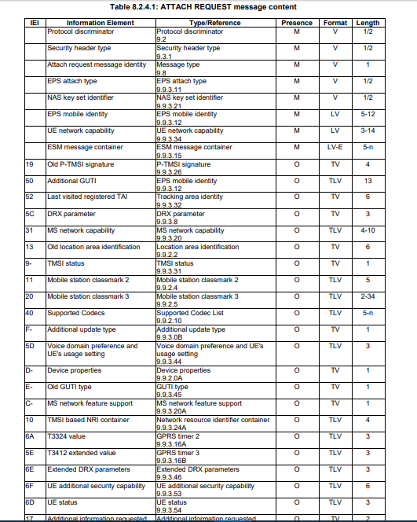

This complete information is present in the ETSI TS 124 301 V15.8.0 (2020-01) and the complete frame formatting of this content is present in the ETSI TS 131 102 V13.5.0.

In this content there is a LAI(location area identification) which contains the free bit reserved for future use.

**2.1.5. Authentication request**

After this the MME sends the authentication request to the HSS this request contains the K-ASME, AUTN, XRES and RAND.

Authentication request content. 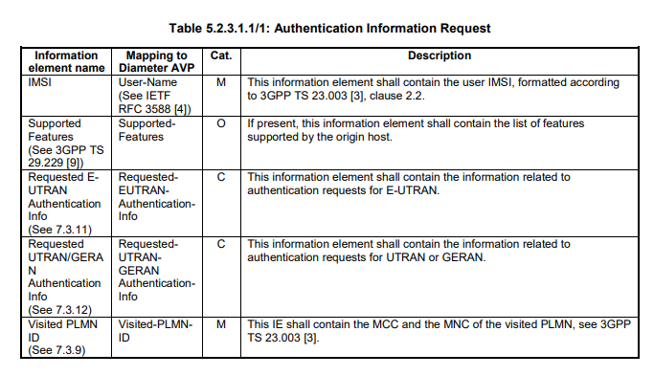

After receiving the authentication HSS match that info with its own database.

And then it will then sends the response message. The content of the response message is

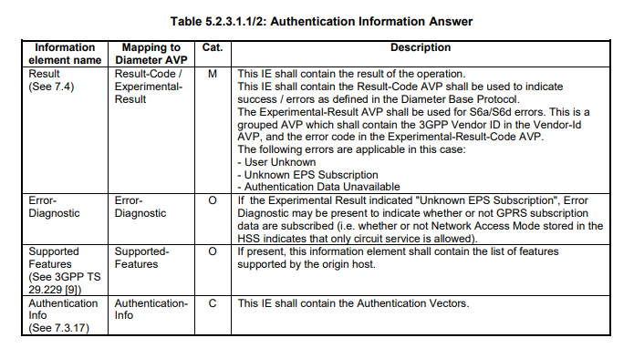

Complete info of this content is present in ETSI TS 129 272 V11.6.0

**2.1.6 Location update request.**

After the PDN request the HSS requests the Location update to the MME. This request also contains the PDN subscription context (EPS subscribed QoS profile and the subscribed APN-AMBR).

After the successful authentication or the Location updation the MME transfer the request to SGW.

**2.1.7 Session Request.**

This message is sends by the MME towards the SGW for creating a GTP tunnel. At this point it will get the IP and a port number. Complete information is in ETSI TS 129 274 V10.5.0

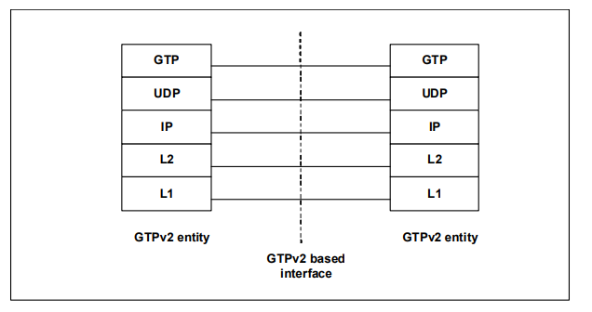

Protocol stack of GTP tunnel.

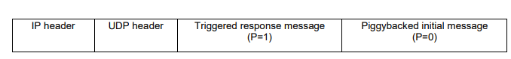

Packet Format for the Piggybacking of messages

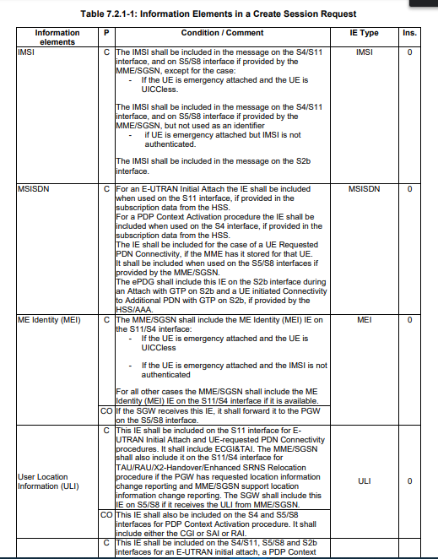

**Session request content complete info is present in** ETSI TS 129 274 V10.5.0

After receiving this session request message from the MME the S-GW

Sends back a response message the complete content of the response message is present in the ETSI TS 129 274 V10.5.0.

After this the SGW sends the **bearer request** to the PGW. The content of this bearer request present in the ETSI TS 129 274 V10.5.0. By the help of this message the PGW will create a new charging id. After this the SGW sends back the session response message to MME. The message shall also be sent by a PGW to an SGW and forwarded to an SGSN as part of the failure of an MS initiated PDP Context modification procedure or secondary PDP context activation procedure.

After receiving the successful bearer message the MME will send eNodeB initial context setup message containing S1 interface context setup request, NAS attachment accept and activate default bearer request. After this the eNodeB will reach the UE with RRC security mode message with the AS integrity protection and encryption algorithms and START parameters. The UE sends to eNodeB acknowledge message that uses the newly activated keys to encrypt and integrity protection. eNodeB will send RRC reconfigure to activate the default radio bearer.

The next thing happening in the LTE call flow is that the UE will send acknowledgment message and attach RRC LTE complete (EPC Bearer Identity, NAS sequence number, NAS-MAC). Now, the UE has successfully established a connection to the network and the buffered data will be passed to the UE in the Data Radio bearer.